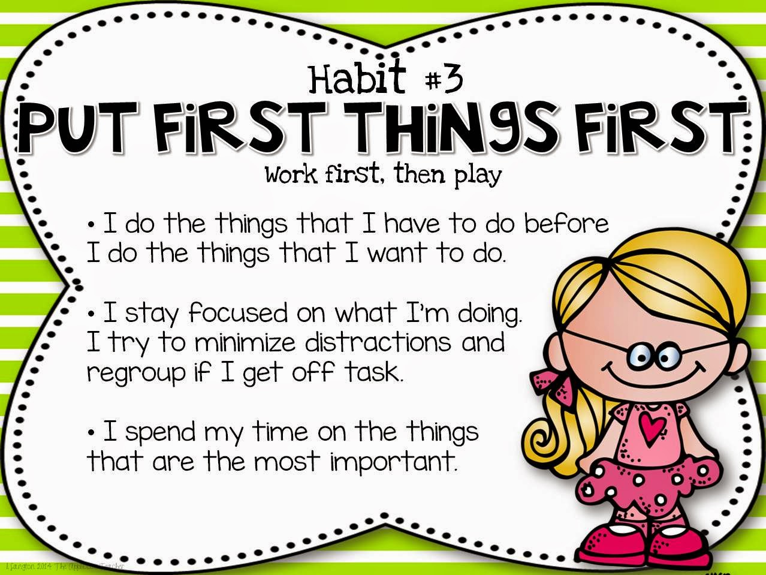

Counseling Corner

Part of putting first things first is taking care of our mental health as well as attending to the things in life that are most important. As parents we have a lot on our plate and usually have a mind full. This is when being mindful is so important. There is a misconception that being mindful means you have to totally empty your mind. Well, that is not really possible. However, it is possible to focus on one thing - like the breath, or the sounds around you, or the smells around you, or the sights you see. This month I am teaching your children that part of putting first things first is taking a mindful moment every day. It helps us navigate the world around us in a positive way and trains our brains to stay calm when life gets crazy. Mindful moments give us strength. I would like to challenge you to have a mindful Thanksgiving this year. This means that instead of gobbling down all the yummy food that took hours and even days to prepare, slow the meal down. Take a moment to notice how the table settings look, how it feels to be sitting together as a family, and have everyone share something they are thankful for. As the food is eaten, notice the flavors and the texture of the food. Eat slower and focus on the meal. Share with each other what food you liked the best, and how it made you feel as you ate it. Having a mindful meal develops good eating habits, manners, gratitude and is a much calmer way to celebrate the holidays.

YOGA CALM

Strength



Mental strength, Emotional strength, and Physical strength are all components of a healthy body. When we are able to increase our physical strength not only do we become more active, but we can feel more secure about ourselves and about the world around us. To help develop physical strength we encourage children to push themselves while listening to their bodies recognizing emotions, thoughts and physical restrictions. Using positive self-talk is one way to increase mental strength. When strengthening our bodies and our minds our emotional health is strengthened.

## 

Utah Food Bank

November 18, 2020

My Contact Information

[megan.gatlin@washk12.org](mailto:megan.gatlin@washk12.org)

435-874-1182

[megan.gatlin@ironmail.org](mailto:megan.gatlin@ironmail.org) 435-586-2855 You will receive a more timely response if you email me as I service two schools.

Water Canyon Elementary November 2020

Praesent laoreet, nunc vel porttitor elementum, sem nisi commodo ante, ut consequat est mi et diam. Praesent dignissim tincidunt libero. Curabitur augue justo, pretium sed, placerat vel, porta eget, pede.

Morbi neque libero, tincidunt adipiscing, aliquam ut, nonummy in, nisi. Integer eu ante. In aliquam ipsum id nisi.

Vivamus vestibulum, lectus interdum dignissim rhoncus, nisi purus condimentum enim, vitae ultrices felis nibh id pede. Nam dictum lacinia diam. Pellentesque venenatis.

#### Consequat id, vulputate eu, nonummy sit amet, nulla.

#### Justo magna dapibus ipsum, quis pulvinar dui mauris quis diam.