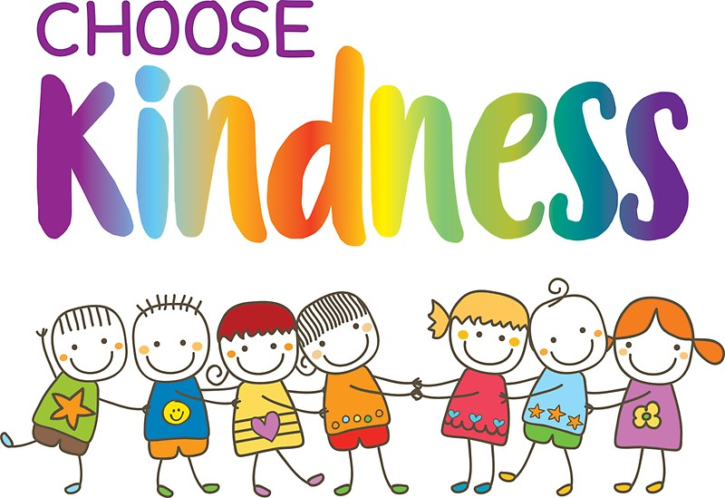

Counseling Corner

Kindness Ideas

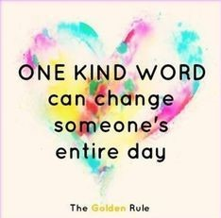

1. Smile at someone
2. Hold the door open for someone
3. Do an extra chore
4. Give someone a compliment
5. Play a game with a sibling
6. Listen and follow directions
7. Spend time with a friend
8. Let someone else go first
9. Give someone a hug or high five
10. Make a new friend
11. Write a kind note to someone
12. Help clean up
13. Say hello to someone
14. Tell someone thank you
15. Pick up trash

November and December are full of festivities and holiday school breaks, so we will not be moving onto Habit 4 until January. However, I am extending a Kindness Challenge to children and their families for the month of December. Each child received a kindness log and the challenge to write down one kind act they perform for another person each day. When they return the kindness log to their teacher on January 5 they will receive a reward. Please support your child in this and help them log their kind deeds. It would also be fun to let everyone take a turn sharing a kind deed that they performed during dinner conversation each night.

Kindness is an important social skill that plays a huge role in creating a positive learning environment for all. When we have kinder children they are better able to work together, share, express differing opinions in respectful ways, and help each other when someone is in need. Families will be more loving, successful, and happy too.



## 

My Contact Information

[megan.gatlin@washk12.org](mailto:megan.gatlin@washk12.org)

435-874-1182

Utah Food Bank

December 16, 2020

[megan.gatlin@ironmail.org](mailto:megan.gatlin@ironmail.org) 435-477-3368 You will receive a more-timely response if you email me as I service two schools.

Water Canyon Elementary December 2020

Praesent laoreet, nunc vel porttitor elementum, sem nisi commodo ante, ut consequat est mi et diam. Praesent dignissim tincidunt libero. Curabitur augue justo, pretium sed, placerat vel, porta eget, pede.

Morbi neque libero, tincidunt adipiscing, aliquam ut, nonummy in, nisi. Integer eu ante. In aliquam ipsum id nisi.

Vivamus vestibulum, lectus interdum dignissim rhoncus, nisi purus condimentum enim, vitae ultrices felis nibh id pede. Nam dictum lacinia diam. Pellentesque venenatis.

#### Consequat id, vulputate eu, nonummy sit amet, nulla.

#### Justo magna dapibus ipsum, quis pulvinar dui mauris quis diam.