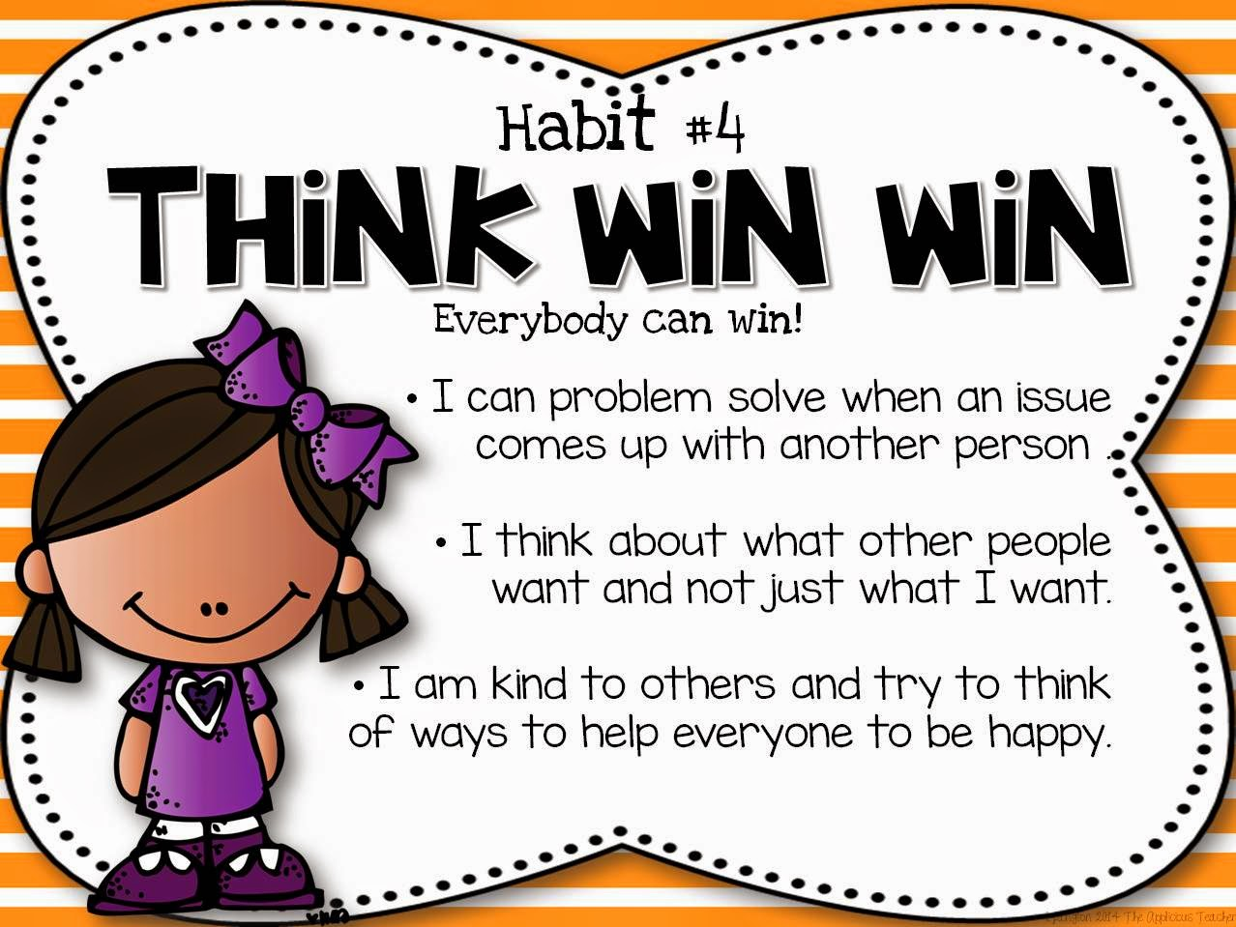

Counseling Corner

YOGA CALM

Strength



Building mental strength can occur by visualizing positive results. As students develop a stronger sense of self, they start to create their own ideas. They begin to be less persuaded by the negative influences around them. As parents we have a huge impact in our children’s development of confidence, self-esteem, and resiliency. Take a few minutes every day to practice yoga with your children. This will help them build strong character.

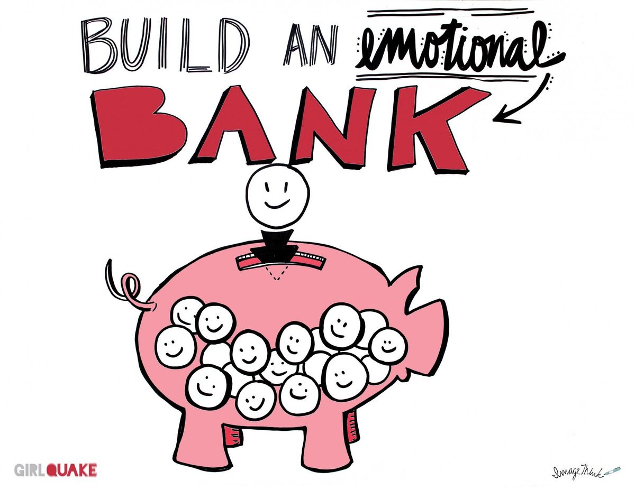

This month your children are learning about thinking win-win. Having a win-win attitude helps us balance our wants with the wants of others. This can create an environment that encourages cooperation and not competition. This month focus on putting more into your children’s emotional bank

accounts than you take out. For every negative

reinforcer we give a child, we must give a

minimum of four positive reinforcers to counteract

the effect of the negative reinforcer. Do you feel

like you are constantly harping on your children?

You are not alone. Just like a regular bank account,

if you constantly make withdrawals eventually

there is nothing left. Putting in more than you take out is always ideal. Track your emotional deposits and withdraws with your children; adjust as needed and see what happens. It takes a little time but after a while as you deposit more than you withdraw you will notice a difference in your relationship with your children, and your home will be a happier place.

## 

Utah Food Bank

Wednesday

January 20, 2021

**My Contact Information**

[megan.gatlin@washk12.org](mailto:megan.gatlin@washk12.org) 435-874-1182

[megan.gatlin@ironmail.org](mailto:megan.gatlin@ironmail.org) 435-477-3368 You will receive a more-timely response if you email me as I service two schools.

Water Canyon Elementary January 2021

Praesent laoreet, nunc vel porttitor elementum, sem nisi commodo ante, ut consequat est mi et diam. Praesent dignissim tincidunt libero. Curabitur augue justo, pretium sed, placerat vel, porta eget, pede.

Morbi neque libero, tincidunt adipiscing, aliquam ut, nonummy in, nisi. Integer eu ante. In aliquam ipsum id nisi.

Vivamus vestibulum, lectus interdum dignissim rhoncus, nisi purus condimentum enim, vitae ultrices felis nibh id pede. Nam dictum lacinia diam. Pellentesque venenatis.

#### Consequat id, vulputate eu, nonummy sit amet, nulla.

#### Justo magna dapibus ipsum, quis pulvinar dui mauris quis diam.