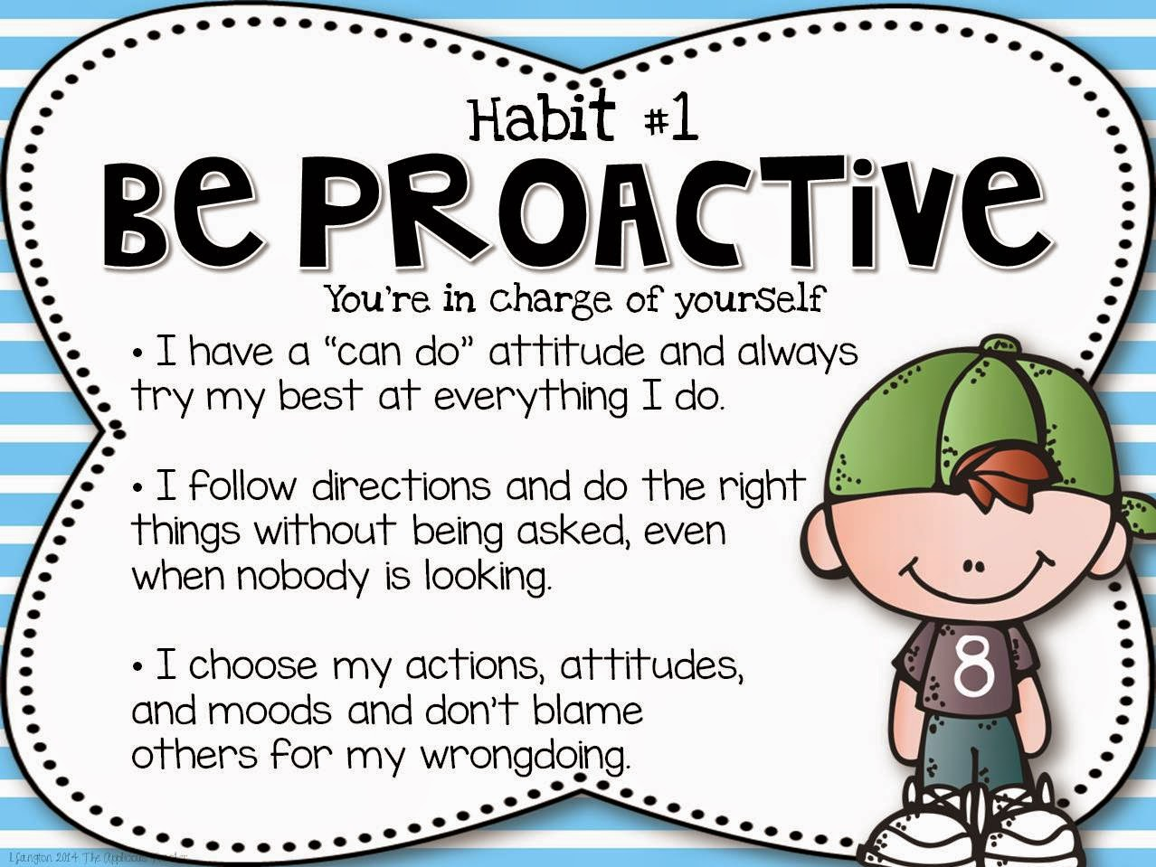

Water Canyon Elementary September 2020

This month our habit is:

Habit #1 Be Proactive.

YOGA CALM

Stillness

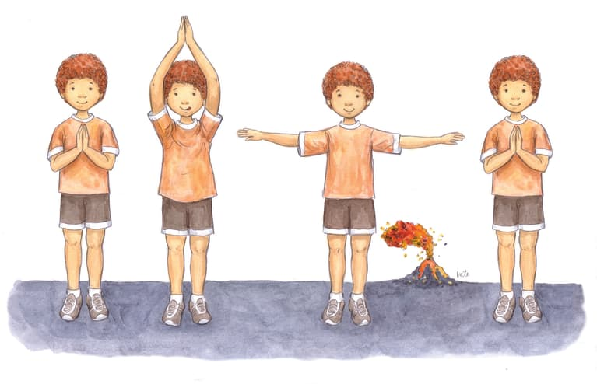

Stillness is a great way to reinforce proactive skills. The benefits of incorporating stillness include increased awareness, calmness, greater creativity, compassion, and sensitivity. Volcano Breathing is one method of increasing stillness and letting go of uncomfortable emotions.

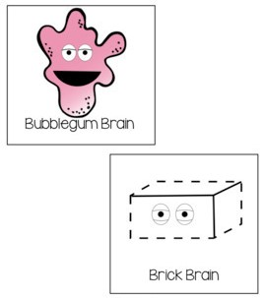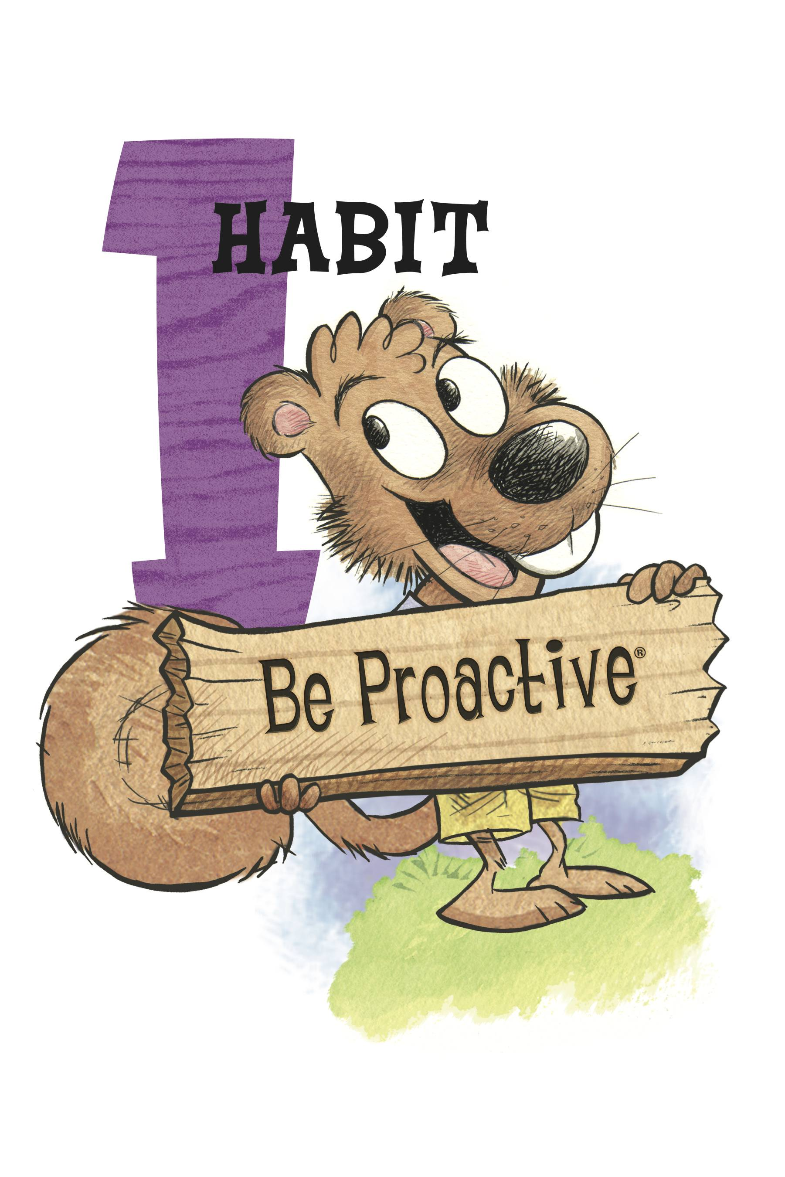

Utah Food Bank

September 24, 2020

Being proactive means that we not only recognize our emotions, but we maintain control of our actions, moods, and attitudes. We can practice this skill by training our brains to stop and think before we react in a negative manner. Proactive people do not blame others or make excuses when mistakes are made. They are accountable for their actions, they take the initiative to make things happen, and they are prepared with the skills they need to remain calm despite experiencing elevated emotions such as sadness, joy, anger, fear, excitement, and frustration.

This month your children will be learning

how to be proactive by having a bubble

gum brain instead of a brick brain.

Learning to grow their mind by flexing,

stretching and bending the way they think will

help them be proactive and appropriately manage

their emotions.

My Contact Information

[megan.gatlin@washk12.org](mailto:megan.gatlin@washk12.org)

435-874-1182

Counseling Corner

Praesent laoreet, nunc vel porttitor elementum, sem nisi commodo ante, ut consequat est mi et diam. Praesent dignissim tincidunt libero. Curabitur augue justo, pretium sed, placerat vel, porta eget, pede.

Morbi neque libero, tincidunt adipiscing, aliquam ut, nonummy in, nisi. Integer eu ante. In aliquam ipsum id nisi.

Vivamus vestibulum, lectus interdum dignissim rhoncus, nisi purus condimentum enim, vitae ultrices felis nibh id pede. Nam dictum lacinia diam. Pellentesque venenatis.

#### Consequat id, vulputate eu, nonummy sit amet, nulla.

#### Justo magna dapibus ipsum, quis pulvinar dui mauris quis diam.