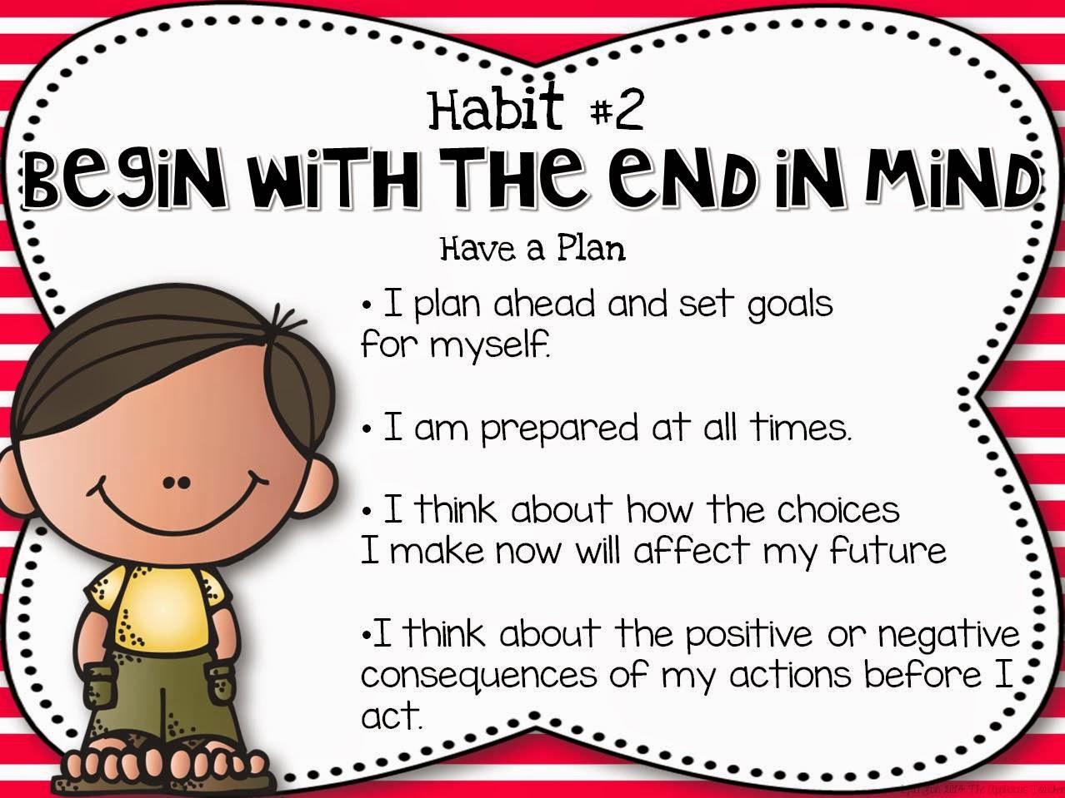

Counseling Corner

Yoga Calm

Community



Communities can provide opportunities for growth and learning by modeling both effective and ineffective behaviors. It is important to prepare our children with realistic expectations and help them develop resiliency in both personal and community life. Being resilient is important when we do not reach our goals or are forced to adjust them because of life changes that are out of our control. The poses we are focusing on this month are Mountain, Tree, Warrior 2, and Eagle.



This month your children will learn to Begin With the End in Mind by exploring who they are, what they like, and where they are going. By exploring what we are good at and who we are, we discover who we want to become and align our behavior and choices with our goals.

We can increase our ability to accomplish goals by planning ahead. Kids are great at imagining what they want to be when they grow up. As adults, we can cheer them on to increase their likelihood of success.

As part of Begin With the End in Mind we will be focusing on healthy lifestyle choices as we celebrate Red Ribbon Week Oct. 26-30. We will be hosting a family night on Oct. 29 from 4:30-6:00. We will serve hamburgers and chips, have a presentation, games, and prizes.

## 

Utah Food Bank

October 14, 2020

My Contact Information

[megan.gatlin@washk12.org](mailto:megan.gatlin@washk12.org)

435-874-1182

[megan.gatlin@ironmail.org](mailto:megan.gatlin@ironmail.org) 435-586-2855 You will receive a more timely response if you email me as I service two schools.

Water Canyon Elementary October 2020

Praesent laoreet, nunc vel porttitor elementum, sem nisi commodo ante, ut consequat est mi et diam. Praesent dignissim tincidunt libero. Curabitur augue justo, pretium sed, placerat vel, porta eget, pede.

Morbi neque libero, tincidunt adipiscing, aliquam ut, nonummy in, nisi. Integer eu ante. In aliquam ipsum id nisi.

Vivamus vestibulum, lectus interdum dignissim rhoncus, nisi purus condimentum enim, vitae ultrices felis nibh id pede. Nam dictum lacinia diam. Pellentesque venenatis.

#### Consequat id, vulputate eu, nonummy sit amet, nulla.

#### Justo magna dapibus ipsum, quis pulvinar dui mauris quis diam.